Cwmlai Playgroup
Statement of purpose
Cwmlai Playgroup is situated on the site of Cwmlai Primary School and access is via our own private access gate on Bethania Hill and not through the School’s main gates.
Cwmlai Playgroup aims to:
Provide high quality sessional day care that enhances the development, care and education of pre-school children in a safe and stimulating environment, where they learn through play in partnership with parents/carers.
Welcome parents/carers who want to become directly involved in the activities of the provision and provide opportunities to do so.
Embrace the ethos and principles of Wales Pre-school Providers Association.
Cwmlai Playgroup is looking forward to sign up to the Welsh Government initiatives by implementing Design to Smile/Healthy Pre-school Scheme.
Legal status: Cwmlai Playgroup is privately owned by Mrs Mair Harris

Cwmlai Playgroup is registered by Care Inspectorate Wales (CIW) under part 2 of the Children and Families (Wales) Measure 2010 to provide sessional day care.
(The person in charge on a day to day basis is: Mair Harris)

The main contact for Cwmlai Playgroup is:
Mair Harris
12 Heol Gelynog, Yorkdale, Beddau, RCT CF38 2SG
Telephone numbers ; 01443 744046 or 07508829654
Email address ; mair_playgroup@hotmail.co.uk
Please contact this person for all enquiries.

Cwmlai Playgroup welcomes boys and girls and is registered by CIW to care for 32 children between the ages of 2 and 4.
CIW registration number is: WO700000821/1
We meet children’s needs as individuals and within groups as a provider of sessional care.
Our latest inspection report by CIW can be seen on www.ciw.org.uk
Cwmlai Playgroup is covered by public liability and employer’s liability insurance. Certificates are displayed on our premises.
Our admissions policy gives details about how applications for admission to Cwmlai Playgroup are managed.

Operational hours: From February 19th 2023
Monday through Friday
9.05am to 12.05pm (pre nursery) without packed lunch
9.05am to 12.15pm (wraparound)
9.05am to 1.00pm (pre nursery) with packed lunch

Staff are recruited, employed within and work to or exceed, regulatory requirements at all times. Cwmlai Playgroup welcomes students on placement, volunteers and visitors who enrich the experiences of children. Policies and procedures that ensure children’s safety and wellbeing are paramount at all times are used.

Facilities available September 2023:
Cwmlai Playgroup moved into a brand-new purpose built early years unit in September 2022, which is located on the grounds of Cwmlai Primary School in September 2022. There is one large open planned inside play area. A designated small kitchen area, where snacks can be prepared. Lunchboxes will be stored in a refrigerator. Children have open access to the outdoors.

Toilet facilities
The toilet houses 3 child sized toilets, hand washing facilities for children and a designated space for nappy changing and staff handwashing.

Outdoor Space
There is also a secure outdoor play area which is the same size as the indoor space.
The outdoor floor is covered in a soft rubber surface. There is also a canopy to give us a shaded area.
The playgroup storage facilities inside and out for storing children's toys and equipment. The playgroup has full use of the school’s woodland area, playing field and large playing yard.
Below is a floor plan of our new premises.
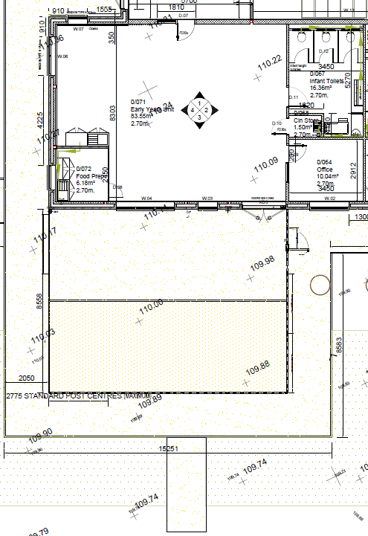

Services offered include snacks/drinks throughout the day in line with our healthy eating policy. Children’s individual needs and preferences are noted and recorded as they register to join the provision. Parents/carers are encouraged to use our ‘settling in’ service to help with their child’s transition to our care.
Activities offered are from a wide range that are planned to suit children’s age, stage and individual needs and meet our aims and objectives. The playgroup’s pedagogy is Birth to five.
We provide adult-led and child-led experiences and are planned, weekly/ daily in advance depending on children’s interest.
Activities are risk assessed and children are encouraged to contribute to any review or evaluation of their experiences as they are able and willing.
A sample of a typical day’s routine is
Morning session
9.05 - 9.15 Registration and settling in time.
9.30 - 12.30: Indoor and outdoor free play (mostly child-led). Also focus activity mostly adult led.
10.15 - 10.45: Rolling snack time which doesn’t interfere or disrupt children’s play.
11.15 - Singing/yoga
11.25 Toileting, handwashing in readiness for lunch for our Wraparound children and pre-school children staying until 1.00.
11.30 Wraparound children and pre-school children staying until 1.00 sit for lunch.
12.00 Pre-nursery children not staying until 1.00 get ready to leave.
12.05 Pre-nursery children are collected.
12.15 Wraparound Children are escorted to the Schools Nursery.
1.00 Pre-nursery children who have stayed for lunch are collected.

Children are encouraged to wash hands regularly, after toileting, before and after using sand and playdough. Children are also encouraged to wash their hands when coming in from the outdoors.
The language used: Cwmlai Playgroup is an English medium setting with some use of Welsh.
Parental involvement: The playgroup believes that parents/carers are the prime carers and educators of their children and as such should be involved in all aspects of the provision. As a member of Early Years Wales, Cwmlai Playgroup welcomes parents/carers who would like to become involved in: Working in the provision on a volunteer basis. (Current restrictions due to covid restrictions)
Fundraising.
The lasting benefit of parental involvement in a child's development and pre-school education is now clearly supported by academic research, as well as providing a lot of pleasure for parents/carers and their children.

Training:
Membership of Early Years Wales and funded training from the RCt childcare team ensures that Cwmlai Playgroup is kept up-to-date with current developments and initiatives in the field of childcare and education. We receive small talk, Early Years Wales magazine, which offers practical advice and up-to-date information, and we are happy to share this with parents/carers. The provision also has access to other publications from Early Years Wales.
Cwmlai Playgroup works with the support of the Childcare Services RCT who have supported us fully with ongoing staff training . Staff have attended a variety of online training, including First Aid, Staff Wellbeing, allergy awareness and Additional Learning Needs modules. Two staff members are currently doing their level 3 qualification in childcare and one other staff member has completed her level 4 qualification in Leadership while another has completed her level 3 qualification in childcare.
Policies and procedures:
Cwmlai Playgroup has produced a pack of policies and procedures that describe arrangements for dealing with routine operational practice, complaints, concerns, and any emergency that may occur during operational hours. They are designed to ensure effective and safe management of our service and to offer the best possible environment and experience for the children and families who use it. The policies and procedures are developed and maintained in line with and/or exceed national minimum standards and regulations. They are reviewed regularly (at least annually) and updated (and CIW informed of any changes) as necessary. The policy pack is available for all who visit, work in or use our serevice to see. Please ask for a copy or visit our website on www.cwmlai-playgroup.co.uk where a comprehensive list of our policies can be found.

Fees are:
Morning sessions
9.05 to 12.05 - £12.00 per session
9.05 to 12.15 - Wraparound - £14.00 per session
9.05 to 1.00 - £16.00 per session
Fees are paid weekly/monthly/half termly depending on parental choice- in advance by bacs payment. Please ask for bank details should you wish to do this. Should twins attend the setting the second child's fees will make reduced payments of £11.00/£13.00 or £14.00 depending on session attended.
Fees are payable if a child is absent without notice or for a short period of sickness/family holiday.
Parents/carers are advised to speak to Mair Harris about payment of fees in cases of prolonged absence.
A child's continued place at Cwmlai Playgroup is dependent on continued payment of fees.

Starting in the provision: Cwmlai Playgroup acknowledges the importance of parents/carers and staff working together to help children settle in the provision and develop confidence to participate in all the activities offered. Some children take longer than others to settle. The treatment of each child as an individual is our main priority. Parents/carers may stay for part of the session, depending on the needs of their child or have a shorter session to help their child settle. (please refer to the admissions policy).
Observations, assessment and record keeping: Cwmlai Playgroup staff take a reflective approach to their work, using observation as a tool to plan activities and ensure children’s needs are met. The progress of children is assessed by observation and recorded. Cwmlai Playgroup has a duty to share some information with the local authority, CIW and in the case of the Child Development Assessment Profile, the Welsh Government. Our records are kept in line with our confidentiality policy and are available for discussion with parents/carers at any time.
The terms and conditions are set out in the contract between parents/carers and Cwmlai Playgroup and implicit within our policies and procedures.
The contract must be signed and the registration form must be completed by parents/carers before their child attends.
Samples of the contract, registration form and the full set of policies and procedures are available from Mair Harris.
CIW and parents’ carers are informed of any changes to this statement of purpose which is reviewed at least annually or as a result of a change in operational practice. (This statement of purpose is supported by Cwmlai Playgroup's operational plan and any changes to one will be reflected in the other.)
Staff
Including the Leader there are six staff. Two of whom holds a cache level 3 in childcare, plus one who has a level 3 plus a level 4 in Leadership and Management, a level 5 being completed next). One member of staff holds a cache level 2 in childcare and has almost completed her level 3, and one other staff member has almost completed a level 3 qualification in childcare. We have one other staff member who is not qualified who we use for emergency cover.
This statement of purpose for Cwmlai Playgroup was passed for use.
On: 14/02/2024 to be reviewed September 2024
By: Mair Harris Position: Leader

